My (bf) Fact Checking using Ontario Gov Covid-19 Statistics.

Interesting point concerning The Ontario Covid-19 Data. I was tracking this data early on in the “pandemic” and finding it was not a close match to what they were saying in the media and by the approved mouth pieces. When the Covid-19 vaccinations were implemented, I noted that the data for vaccines in arms was being shared but the vaccination status in relation to deaths, hospitalizations, and positive Covid-19 tests was not available.

As a result of this lack of data I contacted Ontario Ministry of Health and got hold of someone who was involved in the Covid-19 data collection and publishing. I asked about the vax status data, and was advised that Ontario Health did not have those numbers and that I would have to contact the various Public Health Units and see if they were collecting it and compiling it. Imagine, having to contact every public health unit in Ontario?

I did contact York Region Public Health (health unit for my area) and asked the person involved with the data collection if they were collecting Covid-19 data by vaccination status. The woman I spoke to advised me that, no they were not collecting that data, but were always looking for suggestions of additional data points to include…

A short time after my contact, they started to include this data. But, imagine… who am I, what do I know? I am not part of any science table. It’s like nobody else had considered that this would be important data to collect, especially considering that the vaccine is under emergency order and experimental?

***My contact/emails with the Ontario and Regional governments are included at the end of this document.***

I can work with tables and create my own analysis using the tools in excel, but there is an interesting point in relation to how the Province of Ontario was presenting it online. As well as the tables, Ontario was also publishing the data in graphs as well that were basically an easy-to-understand form of stats for dummies. I continued to monitor and record these stats at the point of each weekly update. As time passed, I observed that per 100K of each group, vaccinated and unvaccinated, that the vaccinated started to show greater proportion of those testing positive for C-19, those dying from C-19, and for those hospitalized. By the early spring of 2022 the vaccinated positive tests and deaths were **2 times** those of the unvaccinated per 100k of each group. By late spring & start of summer, the vaccinated positive tests and deaths were **3 times** those of the unvaccinated per 100k of each group, and the vaccinated represented 75 to 80% or greater of the total covid-19 hospitalizations.

When the vaccinated started to be represented by these disastrous numbers, every government across Canada stopped producing the easy-to-understand graphs and only supplied the tables and the downloadable CSV files. The last graphs they produced were either the last week of June or first week of July 2022. It is interesting that this change took place when it became visible and demonstrated that it was untenable to continue to refer to the Cov-19 vaccines as “safe and effective”. The graphics were an in-your-face contradiction to this perverse approved narrative.

In any case, it was patently obvious, by the mass compliance to the vaccines, that almost no one was going to the available statistics to fact-check what the politicians, government agents, approved medicos, and the pathetic media was selling them.

For Ontario This document was produced by me (bf) sometime in June and July of 2022.

Case number, Spread and Deaths

<https://covid-19.ontario.ca/data/case-numbers-and-spread#time-lag>

NOTE that on the Province of Ontario Covid-19 data webpages the following comments appeared at the end of June and beginning of July 2022:

*“Please note that Cases by Vaccination Status data will no longer be published as of June 30, 2022.*

*“Please note that case rates by vaccination status and age group data will no longer be published as of July 13, 2022.”*

*“Please note that Hospitalization by Vaccination Status data will no longer be published as of June 30, 2022.”*

This suppression of the Covid-19/vaccine data websites took place in every Province in Canada and the Federal Government, they all stopped providing these numbers at the same time… It should not be lost on anyone that the Covid-19 statistics comparing the affects based on vaccine status of the population showed such negative results for the vaccinated and boosted that it contradicted the approved narrative. This should have been a huge embarrassment for anyone who had an ounce of integrity, and resulted in a massive correction and apology. But not for the governments in Canada, for them it was simply the point at which they needed to suppress the data and continue promoting their false, “safe and effective” narrative,

On the left side of the page is the menu of data sources available

<https://data.ontario.ca/en/dataset/covid-19-vaccine-data-in-ontario/resource/c08620e0-a055-4d35-8cec-875a459642c3>

“COVID-19 cases by vaccination status” *is located part way down the page looks like this. If you float your mouse curser over the lines on the graph it will give you the numbers on specific dates.*

*This is reported per 100,000 of each category of Vaccination status, this makes it a real comparison. It is apples to apples, the difference in percent of people vaccinated or unvaccinated is nullified by the formula they use.*

*It is comparing 100,000 people who are all unvaccinated and 100,000 people who are vaccinated.*

*​****For the graph displayed May 27th 2022: PERSONS INFECTED WITH COVID-19 by VACCINATION STATUS****:*

* *Not Fully Vaxxed Today infected with Covid: 4.17 per 100,000. Previously only included those with* ***single shot****.*

***Now includes the UNVACCINATED as well as those with only ONE INJECTION.***

***= This NFV category is a real attempt at masking the truth.*** *Originally 1-shot and unvaxed were separate categories, but because the Unvaccinated were showing the lowest cases of Covid-19 they combined it to include those with 1-shot.*

* *Fully Vaccinated ​on May-26th infected with Covid: 3.77 per 100,000. Includes those* ***vaxed with 2-shots****.*
* ***Vaccinated with BOOSTER ​on May-26th infected with Covid: 8.85 per 100,000.***

*.*

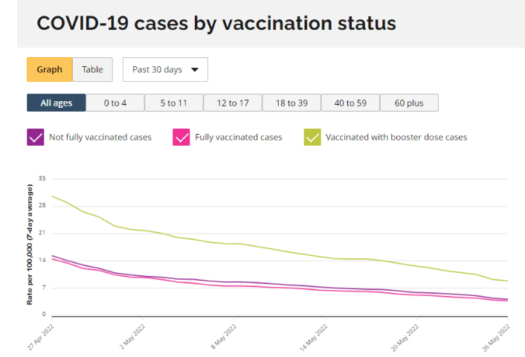

*​​​You can see from these numbers that ​for the dates indicated (in May) twice as many people PER 100K with the booster are infected with Covid than the per 100K number for the single vaxed/unvaccinated (not fully Vaxed).*

*Also, there is almost no difference between the unvaccinated and those with 2 shots. WHAT A JOKE. Remember all this is per 100,000 of each category, it is a numerically equivalent comparison.*

*Scroll down further ​on the website ​to the:****Deaths involving COVID-19 by vaccination status***

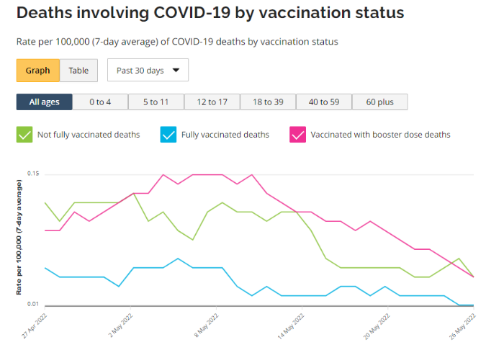

*​Notice how they switch up the colours used for the categories, why would they do that, might it be an attempt to cause confusion?*

*Same comparison method as with the infections graph.*

*The* ***RED line*** *represents those with booster shots,*

*As you can see for​ 26 May the death numbers for* ***partially vaccinated (with includes unvaxed)*** *are about the same per 100K as for the* ***“fully vaccinated****” (Blue line). But if you look at the* ***Red line*** *earlier in ​May the death rate for the boosted was much higher than those* ***partially vaccinated​ (includes unvaxed****)​. ​*

*Even in the stats released for each week in June, those with boosters were shown to have twice the death rate of the* ***unvaxed****. ​And if you​ look at the history of those with* ***two shots (blue line****) it indicates that being****fully-vaxxed (​2-shots)*** *​ provided very little benefit against Covid-19, death, and/or hospitalization.*

​Go back to the top of the page ​and on the left ​click on the “***HOSPITALIZATIONS***”

​Scroll down to the pie charts. ​For a long time now those who are​ vaccinated ​and contracted covid-19 have represented a large percentage of those who are in the hospitals. Their numbers really started to increase since​ ​November 2021.

Pie for “In hospital but not ICU” and:

Pie for “In ICU”

These are direct numbers of people, but just in looking at the PIE graphs you can see that Vaccinated cases of C-19 are over ​80​% ​of those​ in hospital ​and in ICU. When you realize that about 85% are in some state of vaccinated this should not be. It means that the vaccines are having a minimal effect on keeping people out of hospital, and certainly they offer not even close to the protection that we ​continue to be told they do.

Same with ICU. Partially and fully vaccinated represent nearly 83 percent of the patients in Hospital ICUs which is not far off the total percent for all those vaccinated in Ontario. This indicates there may not be any benefit of the vaccines keeping people out of the ICU, and even that it is the vaccines that are impacting on the virus in such as way that is causing more serious illness.

Overall, the greatest fraud ever pulled on the whole world. And they still haven’t figured it out. Basically, conned by a bunch of Snake-oil salesman…. If this is science, they should all find new careers.

**Just a note on how they come up with the /100K comparison:**

*This note is actually for me (bf)*

Rate of COVID-19 cases per 100,000 is calculated by dividing the number of cases for a vaccination status, by the total number of people with the same vaccination status, and then multiplying by 100,000.​

Example 1:

Unvaxed Cases: 10

All Unvaxed People: 300,000

10/300,000 =

x 100,000 = 3.33 per 100,000

Example 2:

Booster Cases: 10

All Boosted people: 3,000,000

10/3,000,000 = 3.33

X 100,000 = .33 per 100,000

*Barry Farndon*

[*batfenderman@gmail.com*](mailto:batfenderman@gmail.com)

*Retd Investigator*

*… Exposing the unfruitful works of darkness (Ephesians 5:11)*

**Original response:**

​On Thu, Nov 18, 2021 at 11:41 AM INFOline (MGCS) <Infoline.MOH@ontario.ca> wrote:

Good Day,

Thank you for contacting ServiceOntario.

ServiceOntario provides general information and referrals concerning Ministry of Health (MOH) programs and services.

You may wish to contact your local Public Health Unit to obtain clarification regarding this inquiry.

Please use the link below to locate a Public Health unit in your region:

<https://www.phdapps.health.gov.on.ca/PHULocator/Default.aspx>

 Regards,

**Andrea**

Customer Care Representative – ServiceOntario

Ministry of Government and Consumer Services

Visit us at: [www.ServiceOntario.ca](http://www.serviceontario.ca/)

1) Ontario Gov inquiry 18 Nov 2021

Infoline.MOH@ontario.ca

[Infoline.MOH@ontario.ca](mailto:Infoline.MOH@ontario.ca)

Please read the question fully before you cut and paste one of your prepared responses. My question can only be answered by someone who works for the Government of Ontario.  I am requesting information that is published on ONTARIO Gov website... https://covid-19.ontario.ca/data.  It is not what is published by local health units. My question involves the covid data numbers that are put together by someone who works for the Ontario Government. It needs to be answered by the person or people from the Ontario Government, probably in the Ministry of Health who make the decisions about what data is and isn't included on the Ontario Government's  website https://covid-19.ontario.ca/data.

Please respond to my question appropriately. Do not make me do the governmental run around, please have the person that has this data provide it to me, or advise me why it is not included. Don't make me call my friend Doug Ford, the Premier.

I look forward to hearing from you, and a proper response,

Thanks you

Barry Farndon,

Here is my original question:

**Message**:

Where can I find the data that includes Covid-19 deaths by vaccination status? Can you please advise me where I can find the deaths amongst the vaccinated from Covid-19. It seems strange, but not surprising that this data is missing from what Ontario is publishing.

​QUESTION 2)

On Thu, Nov 18, 2021 at 3:22 PM INFOline (MGCS) <Infoline.MOH@ontario.ca> wrote:

Good Day,

Thank you for contacting ServiceOntario.

ServiceOntario provides general information and referrals concerning Ministry of Health (MOH) programs and services.

You may wish to contact your local Public Health Unit to obtain clarification regarding this inquiry.

Please use the link below to locate a Public Health unit in your region:

<https://www.phdapps.health.gov.on.ca/PHULocator/Default.aspx>

Regards,

**Andrea**

Customer Care Representative – ServiceOntario

Ministry of Government and Consumer Services

Visit us at: [www.ServiceOntario.ca](http://www.serviceontario.ca/)

**From:** Communications, Finance (MOF) <[FinanceCommunications.fin@ontario.ca](mailto:FinanceCommunications.fin@ontario.ca)>  
**Sent:** November 2, 2021 2:43 PM  
**To:** INFOline (MGCS) <[Infoline.MOH@ontario.ca](mailto:Infoline.MOH@ontario.ca)>  
**Subject:** FW: Reply: Yes, Page: <https://www.ontario.ca/page/government-data>

Hi There,

Please handle the below inquiry directly.

Thank you

MOF CU Team

**From:** DO_NOT_REPLY <[DO.NOT.REPLY@ontario.ca](mailto:DO.NOT.REPLY@ontario.ca)>  
**Sent:** October 22, 2021 1:02 PM  
**To:** Open Government <[opengov@ontario.ca](mailto:opengov@ontario.ca)>  
**Subject:** Reply: Yes, Page: <https://www.ontario.ca/page/government-data>

**CAUTION -- EXTERNAL E-MAIL - Do not click links or open attachments unless you recognize the sender.**

**Referring page**: page/government-data

**Message**:

​​I am trying to locate the data set for number of covid-19 tests conducted that includes a breakdown of the total by vaccination status. To clarify, 1) Total tests conducted on Fully Vaccinated people. 2) Total tests conducted on Partially Vaccinated people. 3) Total tests conducted for Unknown vaccine status. 4) Total people tested who are Unvaccinated. I have looked at the datasets that are available and none appear to contain what I am looking for. As I hope you realize without the total numbers for each sampling group, a true picture of what is actually happening is not possible. Thank you.

**Reply Request**: Yes

**Name**: Barry Farndon

**E-mail**: [batfenderman@gmail.com](mailto:batfenderman@gmail.com)

**Phone number**: 416 557 5778

2) Ontario Gov inquiry 18 Nov 2021

Infoline.MOH@ontario.ca

[Infoline.MOH@ontario.ca](mailto:Infoline.MOH@ontario.ca)

Re: PLEASE READ MY QUESTION..2 ! Reply: Yes, Page: <https://www.ontario.ca/page/government-data>

Please read the question fully before you cut and paste one of your prepared responses. My question can only be answered by someone who works for the Government of Ontario.  I am requesting information that is published on ONTARIO Gov website... https://covid-19.ontario.ca/data.  It is not what is published by local health units. My question involves the covid data numbers that are put together by someone who works for the Ontario Government. It needs to be answered by the person or people from the Ontario Government, probably in the Ministry of Health who make the decisions about what data is and isn't included on the Ontario Government’s website https://covid-19.ontario.ca/data.

Please respond to my question appropriately. Do not make me do the governmental run around, please have the person that has this data provide it to me, or advise me why it is not included. Don't make me call my friend Doug Ford, the Premier.

I look forward to hearing from you, and a proper response,

Thanks you

Barry Farndon,

Here is my original question:

**Message**:

​​I am trying to locate the data set for number of covid-19 tests conducted that includes a breakdown of the total by vaccination status. To clarify, 1) Total tests conducted on Fully Vaccinated people. 2) Total tests conducted on Partially Vaccinated people. 3) Total tests conducted for Unknown vaccine status. 4) Total people tested who are Unvaccinated. I have looked at the datasets that are available and none appear to contain what I am looking for. As I hope you realize without the total numbers for each sampling group, a true picture of what is actually happening is not possible. Thank you.